Ideation Phase
Define the Problem Statements

Date | 06 April 2026
Team ID | 69bd2f9cc71a9ebd6a50e3b1
Project Name | Smart Library request workflow in ServiceNow
Maximum Marks | 2 Marks

Customer Problem Statement Template:
A customer problem statement helps to clearly define the user's needs, challenges, and emotions. It ensures that the system is designed to solve real-world problems effectively.
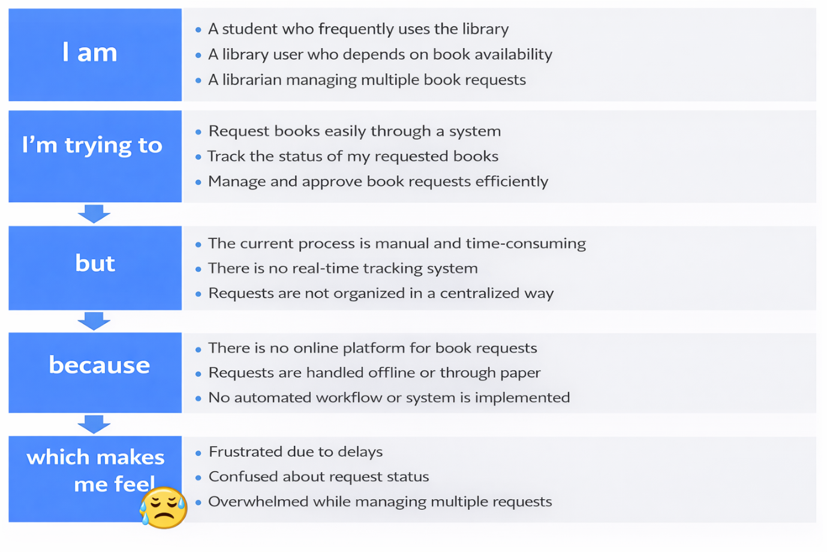
Reference: https://miro.com/templates/customer-problem-statement/

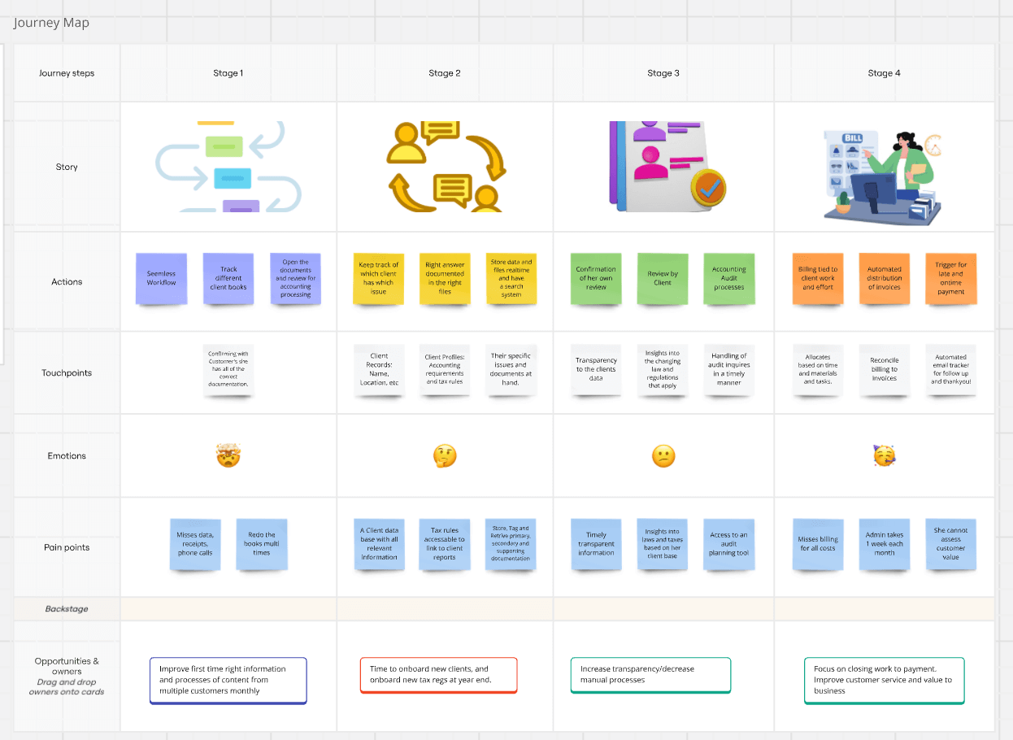
Example:

Problem Statement (PS) | I am (Customer) | I’m trying to | But | Because | Which makes me feel
PS-1 | Student | Request books | Manual process | No online system | Frustrated
PS-2 | User | Track request | No tracking | Offline handling | Confused
PS-3 | Librarian | Manage requests | Not centralized | No workflow | Overwhelmed

